UEI Course Registration System Case Study

Introduction
University Extension Institute (UEI) is a training vendor appointed by Kent Ridge University (KRU) to provide additional training to undergraduate and postgraduate students who are enrolled in a degree programme offered by one of their faculties.
Over the years, KRU noticed that the level of knowledge in certain foundation subjects for new students varied widely. Consequently, some students may not have the necessary prerequisite knowledge to pursue some of their degree course modules. For instance, prior to joining the university, some students may have already acquired good programming knowledge while some may not have any programming skills. Students who do not meet the prerequisites are expected to acquire this knowledge before the module commences at their faculty. One of the accepted methods for meeting prerequisites is to attend short courses at UEI.
All courses offered by UEI are short courses and there could be several runs of the same short course during a year to enable students to complete their prerequisites at a convenient time. KRU heavily subsidises the UEI course fees and students pay a nominal fee for each course they attend. The fee is imposed to discourage them from not attending or dropping out during the course conduct. Upon completing the short course, KRU will reimburse the course fee paid by the students after ensuring that they have fulfilled the attendance requirements.
Each year during the enrolment of new students to their undergraduate and postgraduate programmes, KRU will distribute to them the UEI course list and schedule. The students then make their own decisions as to the courses they want to attend. If they decide to complete their prerequisites at UEI, they would need to visit the UEI office (inside KRU campus) to register for the courses.

System Architecture and Technologies
To manage the university student registration process for UEI short courses, the UEI Course Registration System (CRS) has been proposed, which should be an add-on application module to the institute’s Enterprise Solution. This application should be implemented using Microsoft .NET version 4.0. The Chief Information Officer (CIO) is keen to adopt good software engineering practices and, at the same time, take advantage of the numerous powerful and productive features offered by the .NET platform. The software solution should be designed based on a Layered Architecture to provide effective separation of concerns. In addition, the system should carefully consider relevant enterprise design patterns and use them where appropriate.
A multi-stage roll out of application is planned with the first phase consisting of use cases for internal actors (ie: UEI staff accessing the system through the intranet). In the second phase, internet based functions should be provided for external actors (eg: students directly applying for course via the internet). In a subsequent phase, the application should be integrated with other enterprise applications. The software development for the first and second phases has been completed and software components (façades or back-end layers) have been architected and designed to meet the non-functional requirements of the subsequent phases. The system is browser-based and has been implemented using the Microsoft suite of products and technologies such as ASP.NET, IIS, Windows Advanced Server, COM+ services, SQL Server 2008 and .NET 4.0 framework tools. In addition, the system should also leverage on Microsoft-endorsed technologies such as Java script, AJAX, CSS etc. The system has gone live and has been in stable operation for several months. Satisfied with the progress, UEI is now exploring the creation of services so that inter-application communications can be established using WCF and Web Services. They are also actively considering the use of SharePoint for their portal operations.

Functional Requirements
Note: This section provides high-level specifications that have been scaled down to focus only on the essential information to answer exam questions. If you require additional inputs for answering questions, you may make appropriate assumptions and state such assumptions in your answers.

Use Case Diagram
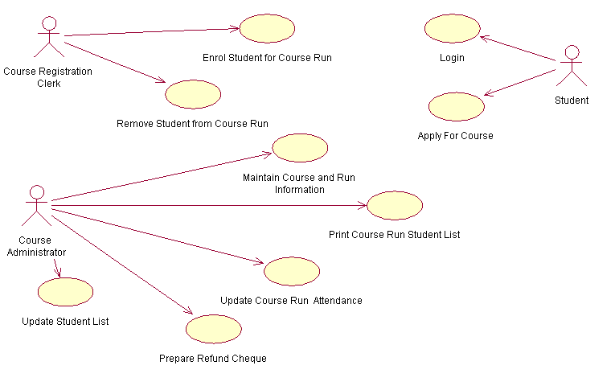
Figure 1: Use Case Diagram - UEI Course Registration System

Actors

Course Administrator
The course administrator keeps track of all courses offered by the institute. Based on historical course demand trends, the administrator plans the number of runs for each course and determines the dates of these runs.

Course Registration Clerk
The clerk is stationed at the UEI office in KRU campus. She handles all student course enrolment and cancellation requests.

University Student
The university student accesses the Course Registration System via the internet and is able to enrol for a course (Note: this is implemented in phase 2).

Use Cases

Enrol Student for Course Run
The use case is invoked by the Course Registration Clerk when a student approaches her for course enrolment. This use case permits her to view a list of courses along with their run dates and seat availability for the next 12 months. Once the student confirms the course date, she collects the payment (cash or cheque) and enters the registration details. The details captured include Student Number, Course Date, Payment Mode and Cheque Number/Date (if payment is by cheque).
Upon successful completion of the registration, the system displays an acknowledgement page which could be printed and handed to the student for reference. In the event of an error, the system reverts to the enrolment page if it is a business rule violation or displays an error page if it is an unrecoverable error.

Maintain Course and Run Information
This use case facilitates the Course Administrator to maintain data pertaining to the various courses offered by the institute. The data representing each course includes Course Name, Course Description, Course Duration (number of days), and Start Date.
All courses are taught during the day, 9.00 am to 5.00 pm, including weekends. The duration of each course is 1, 2, 3, 4 or 5 days, depending on course content, always held on consecutive days. Typically the same course is run several times a year (each referred to as a course-run).

Print Course Run Student List
This use case is invoked to print a list of students who will be attending the course-run. The information presented for each student includes Student Name and Matriculation Number. The Course Name and Course Dates for the run are also printed for marking attendance.
The Course Administrator prints the list and gives it to the lecturer to use it to record the daily attendance of the students.

Remove Student from Course Run
This use case is invoked when a student requests to cancel his enrolment for a course-run. The system will permit the Course Registration Clerk to accept the cancellation request only if the course-run start date is more than 7 days from the time the request is made.

Update Course Run Attendance
At the end of the class, the attendance records of students are updated into the system by the Course Administrator and a report of student attendance for the course-run is generated.

Update Student List
KRU provides in softcopy a list of undergraduate and postgraduate student names and particulars to UEI on a yearly basis, after the matriculation session for the new intake of students is completed. This use case enables the Course Administrator to upload this information into the UEI Course Registration database.

Login (phase 2)
This use case facilitates University Students to login to the system via the internet so that they can make an online course application.

Apply For Course (phase 2)
This use case facilitates University Students to make an online course application by entering their personal details, such as Matriculation Number and the School/Faculty where they are enrolled, and then selecting a course and course-run. The online application would be subsequently used by UEI to enrol the students.

Some key Pre-Conditions / Business Rules in the Enrolment Process
- An applicant (also referred as a student) should be currently studying at KRU having a matriculation number as identity.
- Applicants should pay course fees at the time of enrolment either by cash or cheque. The cheque should not be post dated.
- Students should enroll at least one day prior to the start of the course-run and may enroll up to 12 months in advance.
- A student would be enrolled only if seats are available in the course-run. There is no provision for wait listing.
- A student who has attended a course will not be permitted to enroll for the same course again.
- A student cannot enroll for two courses that overlap each other in terms of start and end dates.

Entity Data Model
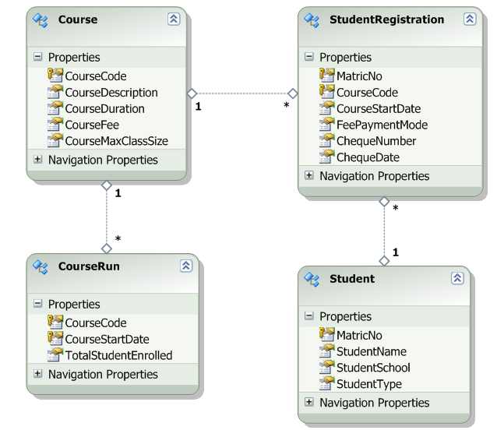
Figure 2: UEI Course Registration Entity Data Model

Enterprise Systems
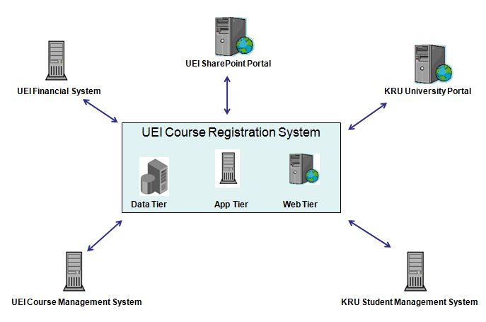
Figure 3: UEI Course Registration System in the Context of Other Enterprise Applications (including Partner Applications)
With the implementation of Phase 3, the distributed systems are expected to be seamlessly integrated with the help of .NET technologies such as WCF and Web services. For instance, the KRU students may have the option of registering for a UEI short course through the KRU Student Management System (at present they need to log in to the UEI website and register). Likewise with the implementation of WCF services, it is expected that the process of preparation of a refund cheque could be accomplished without human interventions since messaging to the UEI Finance System would be enabled (at present a hard copy is prepared from the UEI Course Registration System and sent to Finance Department for preparation of the cheque).

